**First check the vocabulary you know.**

| **Nouns** | **English** | **Verbs** | **English** | **Other** | **English** |
| --- | --- | --- | --- | --- | --- |
| Améliorations |  |  |  |  |  |
| Base de données |  | Acheter |  | Facile d’utilisation |  |
| un client important / essentiel |  |  |  |  |  |
| Compétences |  | Administrer |  |  |  |
| Dépannage |  | Améliorer |  |  |  |
| Un domaine |  | Augmenter |  |  |  |
| Entreprise |  | Fournir |  |  |  |
| Etape |  | Mettre à jour |  |  |  |
| Formation |  | Mettre en place |  |  |  |
| Fonctionnalités |  | Personnaliser |  |  |  |
| Licence |  | Réduire |  |  |  |
| Livraison |  | Visualiser |  |  |  |
| Logiciel |  |  |  |  |  |
| Un retour client |  |  |  |  |  |
| Une tâche |  |  |  |  |  |
| Un utilisateur |  |  |  |  |  |

**Now Look at the CV and check the missing words! Then list the 10 required headings**

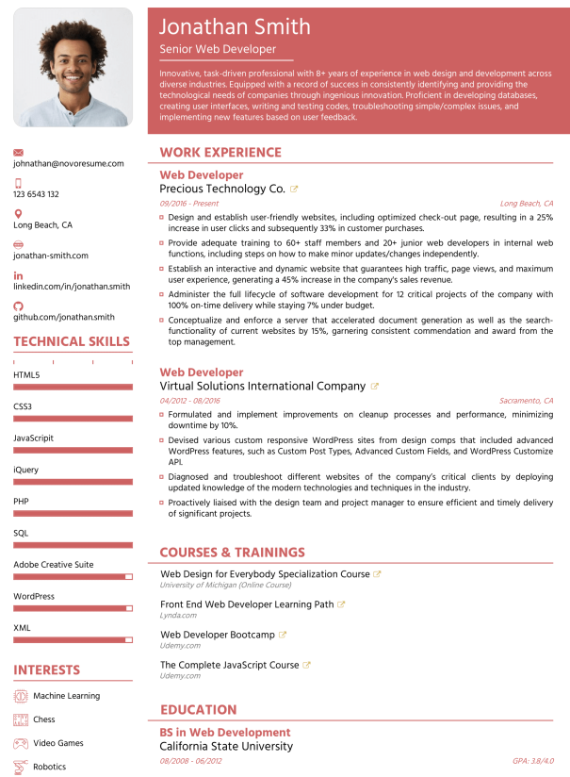

**CV checklist:**

**1** P_________________

**2** J_________________

**3** P_________________

**4** E_________________

**5** P_________________

**6** C_________________

**7** L_________________

**8** I_________________

**9** E_________________

**10** R_________________

**Write about Jonathan Smith. Introduce him to a prospective professional.**